Mathematics: Specialist
Formula sheet Units 3A and 3B

Vectors

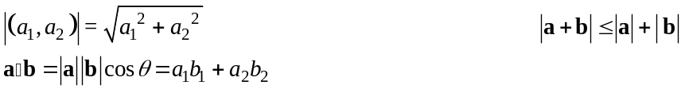

Trigonometry

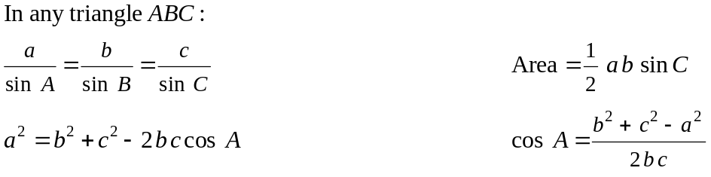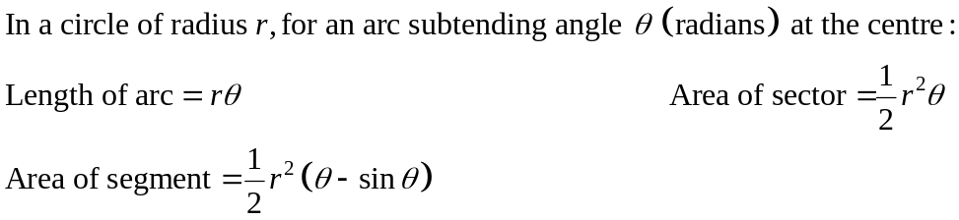
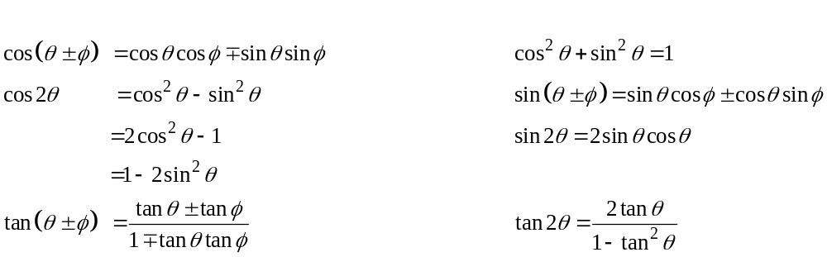

Exponentials and logarithms

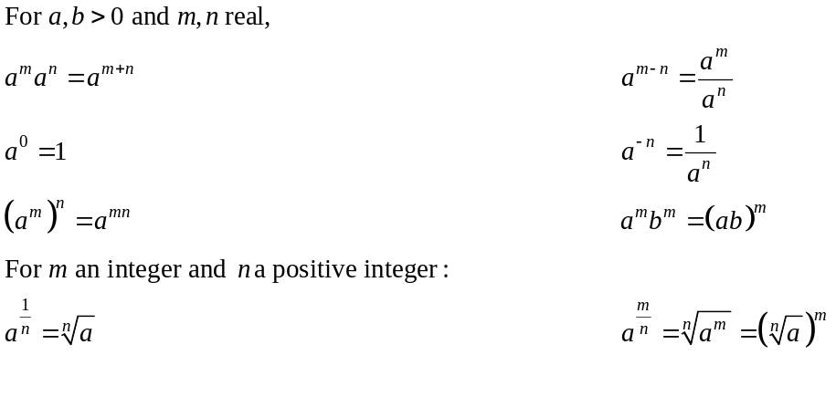
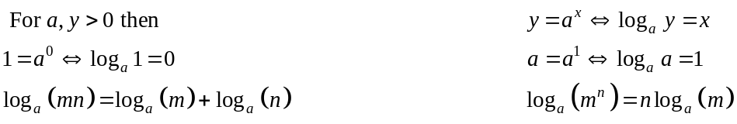

Functions

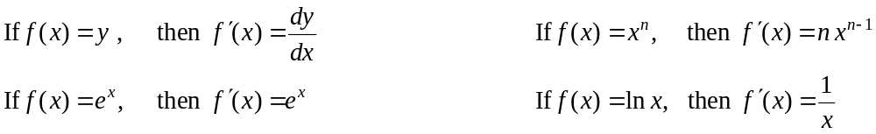

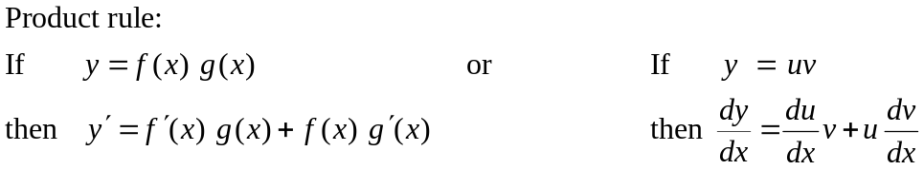

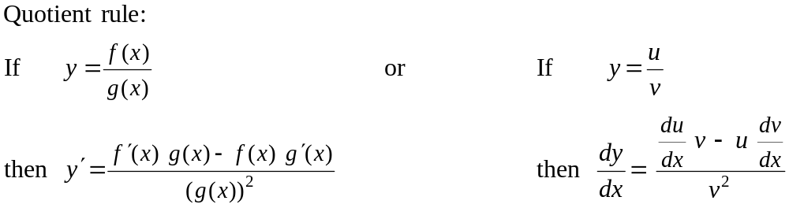

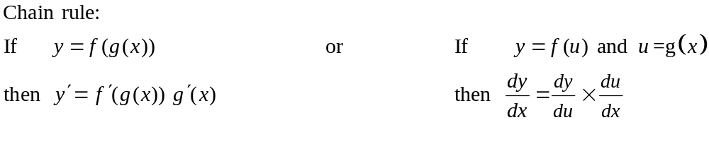
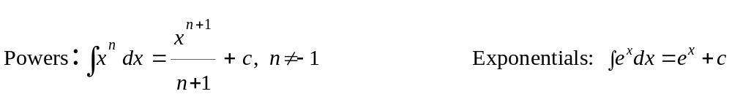

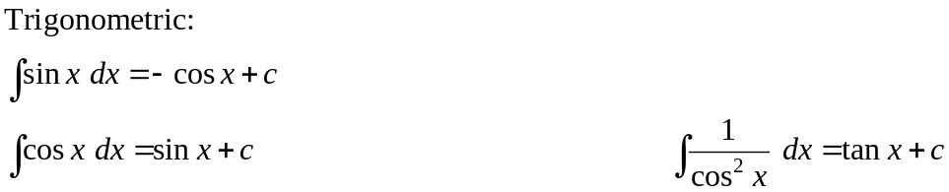
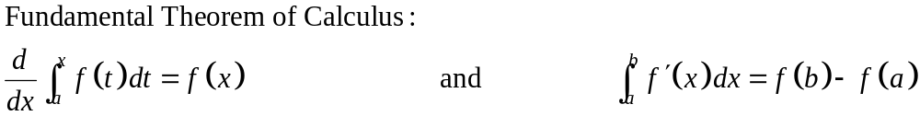
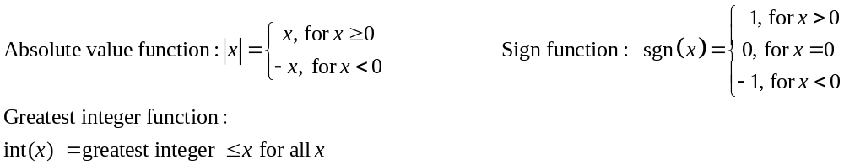

Measurement

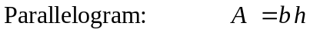
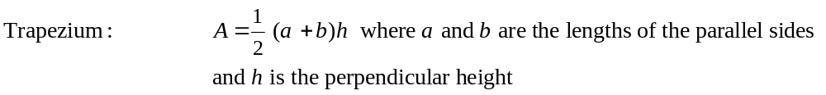
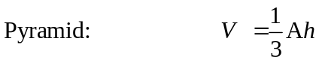
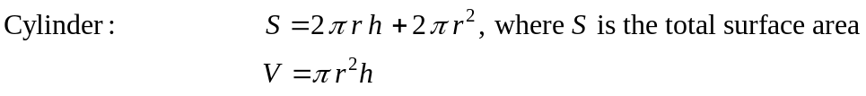
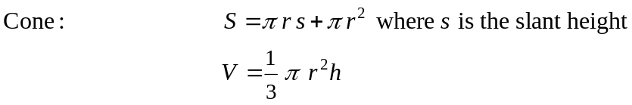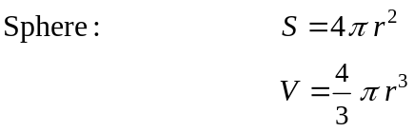

Note: Any additional formulas identified by the examination panel as necessary will be included in the body of the particular question.

